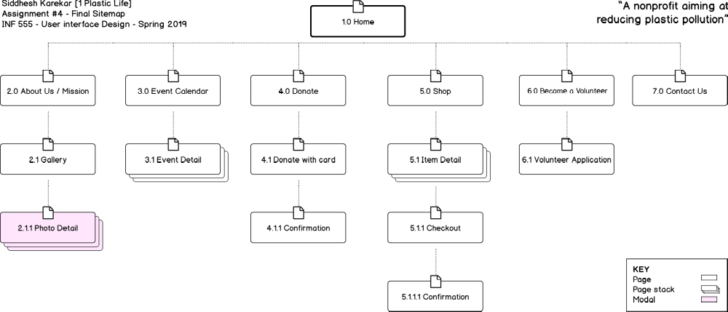
6.0 Become a Volunteer
Button
7.0 Contact Us
Text field
Text field
Text field
Button
3.0 Volunteer Application
Text field
Photo field
Button

5.1.1.1 Buy confirmation
Grid
5.1.1 Checkout
Text field
Text field
Text field
Text field
Button
4.1 Donate with Card
Button
Text field
Checkbox
Dropdown
1.0 Home
Carousel
Button
Navigation
Links
4.0 Donate
Button
Button
5.1 Item Detail
Text Field
Button
5.0 Shop
Grid
3.0 Event Calendar
Grid view
List view
Toggle button
3.1 Event Detail
Button
2.1.1 Photo Detail
Modal
2.1 Gallery
Grid

Features and Functionality

Home (Top Level)
- Banner image
- Carousel – latest 3-4 event links
- Button – call-to-action for donate
- Header – navigation
- Footer – links to social media

2.0 About Us / Mission (2nd Level)
- Images, videos
- Graphs, statistics

2.1 Gallery (3rd Level)
- Photo grid – on click opens modal

2.1.1 Photo Detail (4th Level)
- Modal – zoomed gallery photo

3.0 Event Calendar (2nd Level)
- Grid – calendar style grid view
- List – list style view
- Toggle – toggle between view styles
Each event opens event detail page on click.

3.1 Event Detail (3rd Level)
- Images, videos, event description
- Button – download event as *.ics file

4.0 Donate (2nd Level)
- Blurb about benefits of donation
- Button – External link to PayPal
- Button – Credit card option

4.1 Donate with Card (3rd Level)
- Buttons – preset donation amounts
- Text field – new donation amount
- Check box – is it recurring payment
- Dropdown – recurring period

4.1.1 Confirmation (4th Level)
- “Thank you” text and image
- Link back to home

5.0 Shop (2nd Level)
- Grid – items, images, their prices

5.1 Item Detail (3rd Level)
- Item image, price, description, process of creation, quantity available in stock
- Text field – Quantity to buy
- Button – Buy

5.1.1 Checkout (4th Level)
- Text field – coupon code
- Dropdown – payment method
- Text field – credit card and CVV (if card payment method)
- Text field – address
- Text field – email
- Button – buy

5.1.1.1 Confirmation
- “Thank you” text and image
- Grid – suggested product(s) if any
- Link back to home

6.0 Become a Volunteer (2nd Level)
- Blurb about benefits of joining team
- Button – call-to-action to apply

6.1 Volunteer Application (3rd Level)
- Text fields – various form fields, personal data, links
- Photo field – upload profile picture
- Button – submit application
Upon submission, link back to home with “thank you” popup.

7.0 Contact Us (2nd Level)
- Text field – email
- Text field – name
- Text field – message
- Button – contact us
- Links to social media handles

